Data Validation Report
Alyssa Federle
Data Validation: Quality and Cleaning
August 10, 2025

Validations of Data Sets
Provide counts of rows and columns in all data sets.
Data Set | Row Count | Column Count
Cleaned firm’s data set | 101 | 10
Your company’s data set | 105 | 17
Merged data set | 105 | 24

Report the minimum, maximum, and average values of the quantitative variables (after removing negative values and outliers).
Data Set | Minimum | Maximum | Average
Age | 26.00 | 67.00 | 38.67
Days Employed | 2.00 | 3611.00 | 1309.33

Include data distribution plots for the quantitative variables and confirm if the outlier was removed. You should also specify the outlier value.
Age
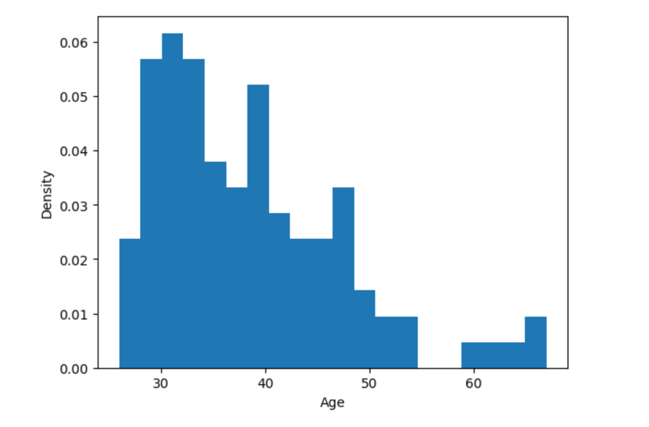
Outlier Value: 139 years of age
As you can see from the graph above the max outlier 139 was removed successfully as the current max value 67 is the highest x value.
Days Employed
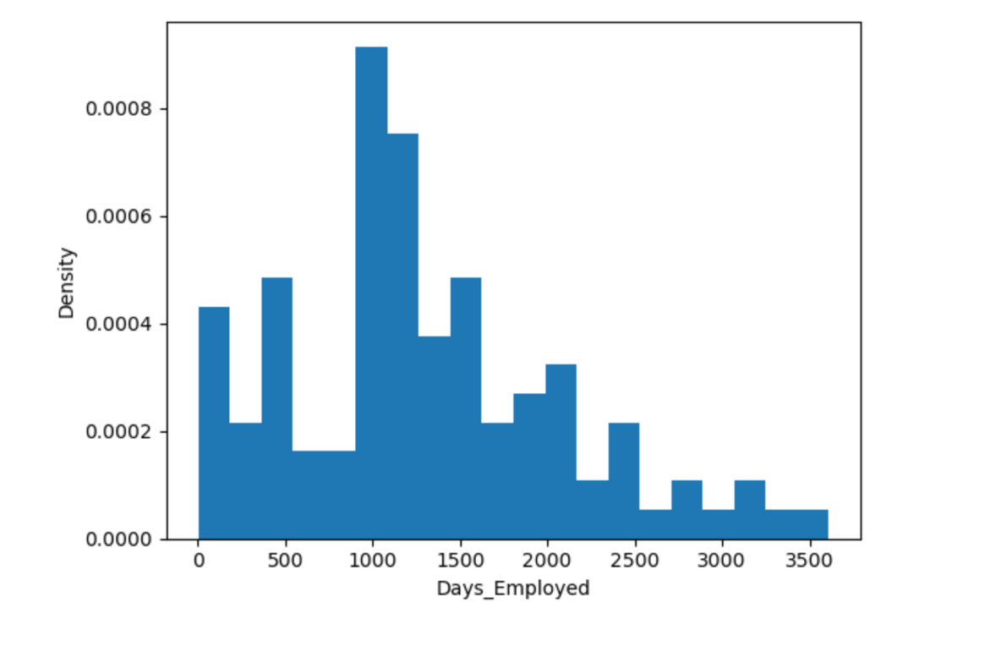
Outlier Value: 52,246 Days Employed
As you can see from the graph above the max outlier 52,246 was removed successfully as the current max value 3,611 is the highest x value.

Summary
In order to clean the data set the quantitative variables Age and Days_Employed were changed. For both variables missing values were filled in with the median value, rows with a negative value were removed, and rows that contained outliers were removed. The categorical variables Marital Status and Citizen_Desc were also cleaned. Missing values were identified and the rows were dropped. A unique function in Pandas library was then used to find incorrect values. This function printed unique values contained in a variable, ‘NotMarried’ and ‘Married’ for Marital Status and ‘US Citizen’ and ‘Eligible NonCitizen’ for Citizen_Desc values. After these data cleaning steps were finished I performed a data transformation to join the firm’s data with our company data. The final data import will be clean and of the highest quality for these four variables as there are no missing values, significant outliers, or incorrect values that affect the final data set.
Resources
Nassirova, E. (2024, November 30). Data cleansing vs. data transformation. Coupler.io Blog. https://blog.coupler.io/data-cleansing-vs-data-transformation/

